**Problem 1:** Analytical expression obtained for part b bullet #1 contained on last page of the stapled assignment sheet. For part b bullet #2 centered 3 point differencing equations were used to find the solution.

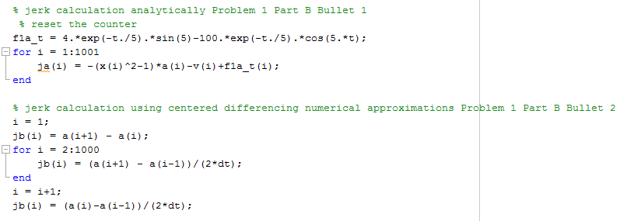





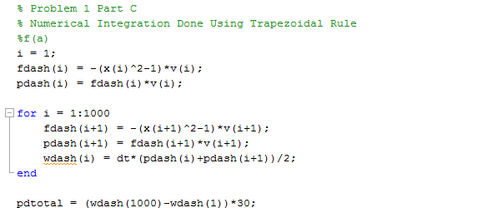  
Final result for the power dissipated by the dashpot over the entire time is -.7067 or

**Problem 2:**

The linear model fit when solved using the matlab cftool returns a value of 3725 for the slope and -260.3 for the y intercept. This makes sense because when diamonds become too small, they are no longer suitable for rings because the setting becomes worth much than the diamond and the visual appearance of a diamond becomes that less obvious. Therefore before the diamond weighs nothing the value for a diamond to put in a ring becomes 0. Forcing the data through the origin does not help the fit and makes the fit only reasonable between ~.175 carats and ~.275 carats instead of the whole range.



Sensibility of Non-Linear Fits:

* Power Fit: The power fits neither the higher or lower sizes of diamonds with a starting value at the origin which doesn’t make sense for diamonds for rings.
* Exponential Fit: The exponential fit is far better than both the power and linear fit through the origin. Also, the exponential is closer to more values than the exponential raised to a polynomial. For both the highest and lowest values, it comes fairly close in the fitting.
* Exponential Raised to a Polynomial: This fit works decently well, but doesn’t make much sense to use because a simple exponential equation fits better than this complicated exponential. For both the highest and lowest values, it comes fairly close in the fitting.

None of the non-linear fits come as close to the majority of values as does the straight linear fit of the data.